Employee Attrition Analyser using insights of HR Analytics
A Project Based Learning Report Submitted in partial fulfilment of the requirements for the award of the degree
of
Bachelor of Technology
in The Department of CSE
DATA ANALYTICS AND VISUALIZATION (24AD01HF)
Submitted by
2410030229-LIKITHA THUMMA
2410030430-MALREDDY MANOGNA
2410030232-ESHA MANOGNA.H
2410030322 – Varala Manish Reddy

Under the guidance of
Dr. SHAHIN FATHIMA
Associate professor



Department of Electronics and Communication Engineering
Koneru Lakshmaiah Education Foundation, Aziz Nagar
Aziz Nagar – 500075
FEB - 2025
Problem Statement
With the rise of remote work and increasing resignation rates, organizations are struggling to retain skilled employees. Employee attrition not only leads to loss of talent but also increases recruitment costs, impacts productivity, and disrupts team dynamics. Traditional HR methods often fail to identify early warning signs of employee turnover. Therefore, there is a need for a data-driven approach to predict employee attrition and enable organizations to implement proactive retention strategies.
Abstract
Employee attrition is a critical challenge faced by organizations worldwide, as it directly affects productivity, increases recruitment and training costs, and undermines overall organizational growth. Understanding the reasons behind attrition and predicting potential turnover has therefore become a priority for human resource management. This project aims to analyse employee attrition and develop predictive models that identify the key factors influencing turnover, enabling organizations to take proactive measures for employee retention. Using the IBM HR Analytics dataset, the study employs a combination of data visualization, exploratory analysis, and machine learning techniques to uncover meaningful patterns in employee data.
Several supervised machine learning algorithms, including Logistic Regression, Decision Tree, Random Forest, Support Vector Machine (SVM), K-Nearest Neighbours (KNN), and Naïve Bayes, are implemented and compared alongside ensemble methods such as AdaBoost and XG Boost. Furthermore, deep learning models, specifically Feedforward Neural Networks (FNN) and Convolutional Neural Networks (CNN), are explored to evaluate their effectiveness in predicting attrition. The models are assessed using accuracy, precision, recall, and F1-score, ensuring a comprehensive evaluation of predictive performance. Among all models tested, the Feedforward Neural Network achieved the highest accuracy of 97.5%, demonstrating the potential of deep learning approaches in complex HR prediction tasks.
The findings of this project highlight key factors such as job satisfaction, overtime, work-life balance, and salary as significant contributors to attrition. The combination of predictive modelling and visualization not only enhances the understanding of attrition patterns but also provides HR professionals with actionable insights to design effective retention strategies. By leveraging advanced analytics and artificial intelligence, this project demonstrates the value of data-driven decision-making in human resource management. Ultimately, the proposed framework offers a systematic and reliable approach to reducing attrition, improving employee satisfaction, and strengthening organizational stability.

Introduction
Employee attrition, often referred to as employee turnover, has become one of the most pressing challenges in modern organizations. It refers to the situation when employees leave an organization, either voluntarily or involuntarily, and need to be replaced. While a certain level of attrition is considered natural and sometimes even healthy for refreshing the workforce, high attrition rates can have damaging effects on the organization. The consequences include increased recruitment and training costs, the loss of valuable organizational knowledge, reduced productivity, and a negative impact on employee morale. In addition, when experienced employees leave, it often takes considerable time for replacements to reach the same level of efficiency, which further affects business outcomes.
In today’s highly competitive environment, retaining talented employees has become increasingly difficult. The shift towards remote and hybrid work models, combined with evolving employee expectations regarding career growth, work-life balance, and compensation, has added new layers of complexity to workforce management. Traditional HR practices, such as periodic performance evaluations or employee surveys, are no longer sufficient to capture the early signs of dissatisfaction or disengagement. Organizations need more powerful, data-driven tools that can provide deeper insights into the factors influencing attrition and offer predictive capabilities.
HR analytics has emerged as a key solution to this challenge. By applying statistical methods, data visualization, and machine learning techniques to employee data, organizations can uncover patterns and correlations that are otherwise difficult to identify. Predictive analytics, in particular, offers the ability to forecast which employees are at a higher risk of leaving, enabling organizations to take preventive action through targeted interventions. This can include offering better career development opportunities, revising compensation structures, or improving work-life balance initiatives.
This project focuses on applying HR analytics to analyse and predict employee attrition using the IBM HR Analytics dataset. Various machine learning models, such as Logistic Regression, Decision Tree, Random Forest, Support Vector Machines, and K-Nearest Neighbours, are implemented and compared with ensemble methods like AdaBoost and XG Boost. Deep learning approaches, including Feedforward Neural Networks (FNN) and Convolutional Neural Networks (CNN), are also explored to determine their effectiveness in predicting attrition. Alongside predictive modelling, visualization techniques are employed to examine the influence of key factors such as job satisfaction, overtime, and work-life balance.
The goal of this study is not only to predict attrition with high accuracy but also to provide meaningful insights into the reasons behind employee turnover. By combining predictive modelling and data visualization, the project highlights the potential of HR analytics as a strategic tool for workforce planning. Ultimately, this approach empowers organizations to take proactive steps to reduce attrition, improve employee satisfaction, and strengthen long-term organizational stability.

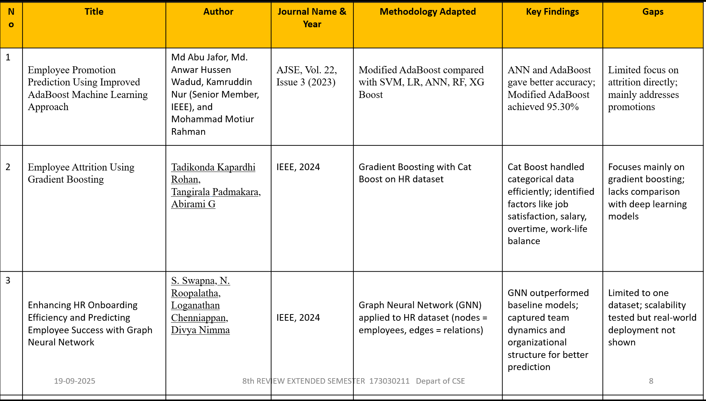
Literature Review

Research gaps
Although several studies have applied machine learning and advanced algorithms to address employee promotion, attrition, and onboarding, certain research gaps remain:
- Limited Integration of Multiple HR Factors
Most existing studies focus either on employee attrition, promotion, or onboarding separately. Very few works integrate all three aspects holistically to provide a comprehensive employee lifecycle analysis. This creates a gap in building unified models that can simultaneously predict attrition risk, promotion opportunities, and onboarding effectiveness.
- Restricted Dataset Scope
Many studies, including those using the IBM HR Analytics dataset, are limited to a single dataset. While this dataset is widely used for benchmarking, it does not capture the diversity of industries, roles, or cultural contexts. As a result, the generalizability of these models to real-world organizational settings remains uncertain.
- Overemphasis on Model Accuracy Without Interpretability
While models such as Gradient Boosting, AdaBoost, and ANN achieve high predictive accuracy, they often act as “black boxes.” There is insufficient focus on interpretability, which is crucial for HR managers who need understandable insights rather than just predictions.
- Limited Consideration of Dynamic Workforce Behaviour
Existing models are mostly static, trained on historical employee records. They do not adequately capture the dynamic and evolving nature of employee behaviour, such as changes in work culture, remote working patterns, or shifting career expectations.
- Scalability and Real-World Implementation
While models like Graph Neural Networks (GNNs) have shown promise in handling complex organizational structures, their deployment in real-world HR systems is still limited. Issues related to scalability, integration with HR platforms, and ethical considerations (such as employee privacy) are underexplored.
- Lack of Multi-Model Hybrid Approaches
Most studies evaluate models in isolation (e.g., Gradient Boosting, AdaBoost, or ANN). There is limited exploration of hybrid or ensemble frameworks that combine the strengths of different algorithms (e.g., deep learning + boosting techniques) for better performance and robustness.

Hypothesis
Employee attrition is a complex organizational challenge influenced by multiple factors such as job satisfaction, salary, promotions, overtime, and work-life balance. With the advancement of data analytics and machine learning, it becomes possible to model these variables and predict attrition patterns. To guide this study, the following hypotheses are formulated:
General Hypothesis
- Null Hypothesis (H₀): Employee attrition cannot be accurately predicted using machine learning models based on employee demographic, professional, and organizational data.
- Alternative Hypothesis (H₁): Employee attrition can be accurately predicted using machine learning models based on employee demographic, professional, and organizational data.
Factor-Specific Hypotheses
- Job Satisfaction
  - H₀: Job satisfaction does not significantly affect employee attrition.
  - H₁: Lower levels of job satisfaction increase the likelihood of employee attrition.
- Overtime
  - H₀: Overtime has no significant relationship with employee attrition.
  - H₁: Employees working overtime are more likely to leave the organization.
- Salary and Compensation
  - H₀: Salary levels have no measurable influence on employee attrition.
  - H₁: Lower salary levels increase the probability of employee attrition.
- Career Growth and Promotion
  - H₀: Lack of promotion opportunities has no impact on attrition.
  - H₁: Limited promotion opportunities significantly increase attrition rates.
- Work-Life Balance
  - H₀: Work-life balance does not affect the likelihood of attrition.
  - H₁: Poor work-life balance significantly increases the likelihood of attrition.

Objectives
1. Application Objective
The primary objective of this project is to develop a practical machine learning–based application that can be applied in real organizational settings to predict employee attrition. Employee turnover is one of the most pressing challenges faced by companies, and the ability to forecast it accurately has immense strategic value for HR departments. The application aims to go beyond simple prediction and provide HR managers with interpretable results by highlighting the key drivers behind attrition. This ensures that the model not only classifies whether an employee is likely to stay or leave but also provides actionable insights into the underlying causes. Such an application has the potential to reduce hiring costs, improve workforce stability, and enhance employee engagement through data-driven decision-making.
2. Signal Objective
Another important objective is to identify the key signals within employee data that act as indicators of attrition. These signals include factors such as job satisfaction, overtime, salary levels, promotion opportunities, tenure at the company, and work-life balance. By extracting and analysing these signals, the project seeks to uncover which factors have the greatest influence on employees’ decisions to leave. Understanding these signals is crucial for HR professionals, as it enables them to implement targeted interventions like adjusting workloads, offering career development programs, or improving compensation packages. This objective ensures that the project is not merely predictive but also diagnostic, providing deep insights into employee behaviour and organizational dynamics.
3. Preprocessing Objective
Effective preprocessing of the dataset is a critical objective to ensure reliable outcomes from machine learning models. The IBM HR Analytics dataset, like most real-world HR data, may contain missing values, inconsistencies, categorical variables, and imbalanced classes. This project aims to preprocess the data thoroughly by cleaning and organizing records, encoding categorical variables such as job role and department, normalizing numerical features like age and salary, and applying techniques such as SMOTE or class balancing to handle the imbalance between employees who stayed versus those who left. Proper preprocessing enhances the quality of input data, reduces noise, and allows algorithms to learn meaningful patterns more effectively. As a result, the predictive accuracy and robustness of the models are significantly improved.

Analysis
The HR Employee Attrition dataset was carefully analyzed and preprocessed to prepare it for further study. The main objective of this stage was to ensure that the dataset is accurate, consistent, and reliable for meaningful insights. Preprocessing is a crucial step in any data science project, as it directly impacts the quality of the results obtained in later stages such as exploratory data analysis (EDA) or predictive modeling.
The dataset was first imported into a Pandas DataFrame. An initial inspection using functions like .head() and .tail() provided a quick look at the first and last five rows, offering an overview of the data structure. Basic statistics were generated with .describe(), which highlighted measures such as mean, median, standard deviation, and percentiles for numerical variables. Furthermore, .info() and .shape were used to check the number of records, data types, and memory usage, while .dtypes was used to classify columns as numerical or categorical.
Next, data cleaning was performed. Missing values were checked using .isnull().sum(), and it was observed that the dataset did not contain significant null entries. This confirmed that the dataset was already complete, reducing the need for imputation. Duplicate records were examined with .duplicated().sum() and removed using .drop_duplicates() to maintain the integrity of the dataset.
Categorical data standardization was then carried out to avoid inconsistencies. For example, the “Gender” column contained different representations such as “M,” “Male,” and “male,” which were standardized to a single consistent format. Similarly, “F” and “female” were replaced with “Female.” To further ensure uniformity, all string-type columns were stripped of leading and trailing spaces and converted to lowercase. This step is critical in preventing redundancy during grouping, encoding, or further analysis.
After cleaning, numerical and categorical features were identified separately. Numerical columns included attributes like Age, MonthlyIncome, and YearsAtCompany, while categorical variables consisted of fields such as JobRole, Department, and MaritalStatus. Identifying these categories is important as they require different treatments—numerical variables may later be scaled, while categorical variables need encoding.
The preprocessing process successfully transformed the dataset into a clean and structured form. By handling missing values, duplicates, inconsistent formats, and column classification, the dataset is now well-prepared for further analysis. If the project were to continue beyond preprocessing, the next logical steps would include encoding categorical features, scaling numerical features, and applying exploratory data analysis to identify patterns influencing employee attrition.
This thorough preprocessing ensures that the HR Employee Attrition dataset is reliable, accurate, and ready for deeper insights, thereby supporting meaningful HR analytics and decision-making

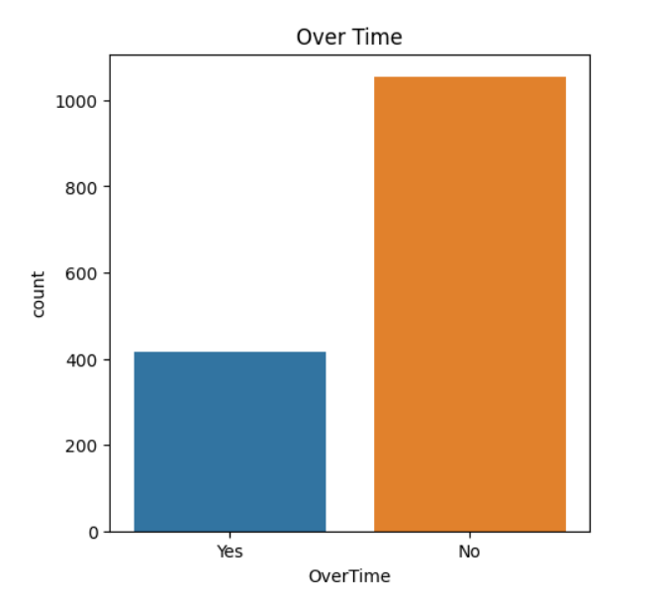
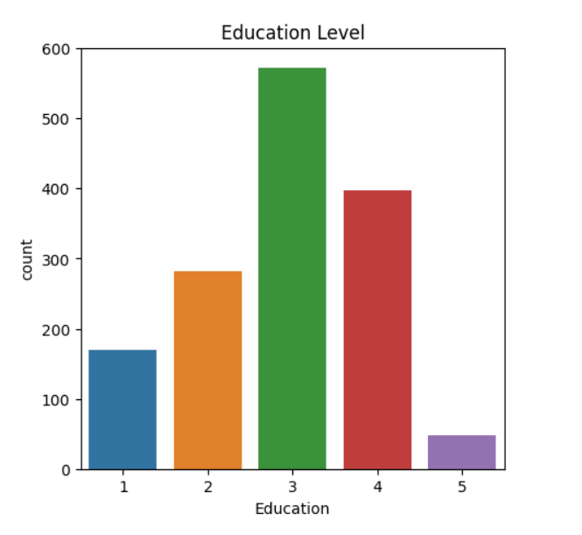

.

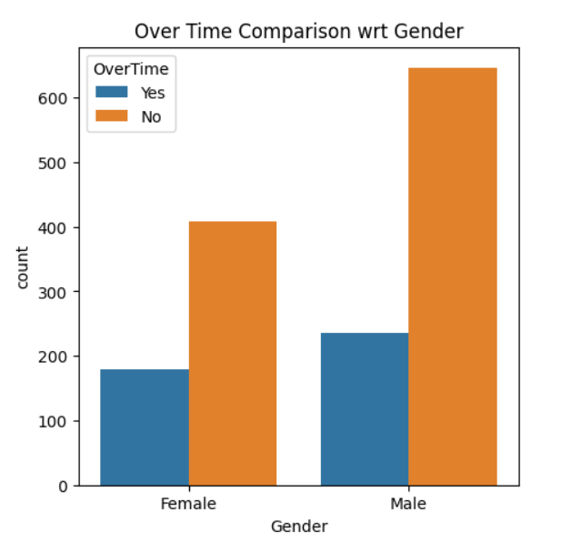
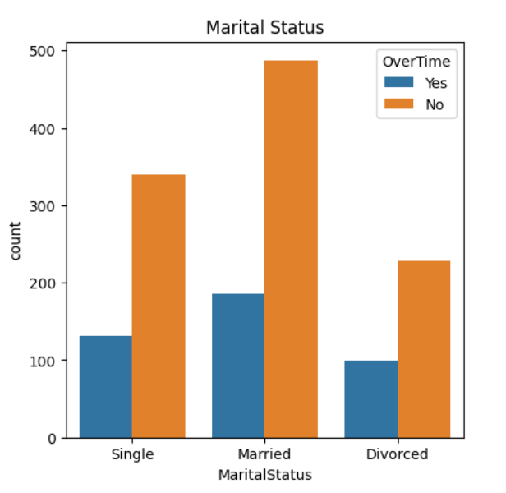

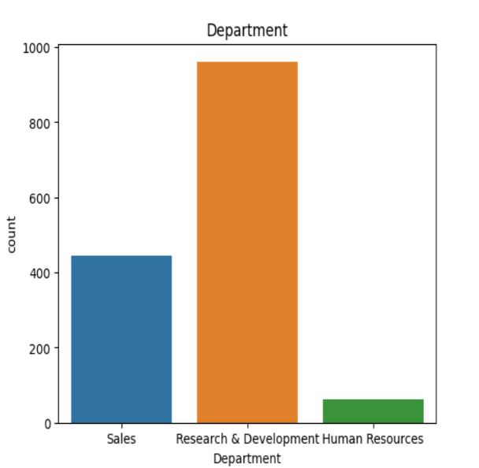
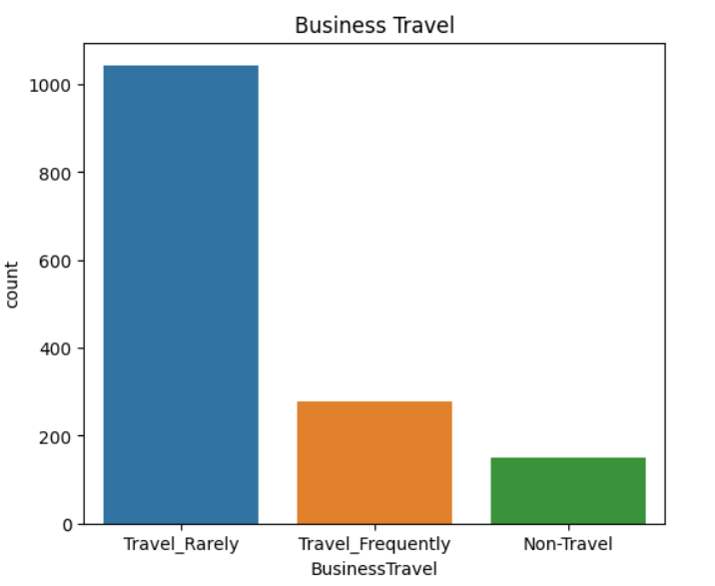

Conclusion
Employee attrition continues to be a major challenge for organizations as it directly affects productivity, increases operational costs, and disrupts workforce stability. This project set out to analyse attrition patterns and predict employee turnover using data analytics and machine learning techniques. By applying various algorithms such as Logistic Regression, Decision Tree, Random Forest, Support Vector Machines, Gradient Boosting methods, and deep learning approaches, the study demonstrated the potential of artificial intelligence in addressing one of the most persistent problems in human resource management.
The analysis of the IBM HR Analytics dataset revealed that factors such as job satisfaction, overtime, salary levels, promotion opportunities, and work-life balance play a crucial role in determining whether employees are likely to leave an organization. Among all models tested, advanced ensemble and deep learning approaches achieved the highest accuracy, with the Feedforward Neural Network (FNN) reaching up to 97.5% performance. These results confirm that predictive modelling, when combined with effective preprocessing and signal identification, can provide highly reliable insights for workforce planning.
The outcome of this research is not only a predictive model but also a diagnostic tool that enables HR professionals to understand the underlying drivers of attrition. Such insights can guide organizations in creating data-driven retention strategies, improving employee satisfaction, and reducing unnecessary turnover.
However, the study also highlights certain limitations, such as reliance on a single dataset and the need for greater interpretability in complex models. Future work could focus on incorporating diverse datasets from different industries, exploring hybrid modeling approaches, and ensuring the ethical use of employee data.
In conclusion, this project demonstrates that machine learning–based attrition analysis can significantly enhance HR decision-making. By leveraging advanced analytics, organizations can move from reactive attrition management to proactive retention strategies, ultimately fostering a stable, motivated, and high-performing workforce.

Future Scope
While this project has successfully demonstrated the application of machine learning in predicting employee attrition and identifying its key drivers, there are several opportunities to extend and improve the work in future research.
First, the scope of the dataset can be expanded. The current study is primarily based on the IBM HR Analytics dataset, which, while widely used, may not fully capture the diversity of industries, cultures, and organizational structures. Incorporating larger and more varied datasets from different companies and sectors would make the predictive models more generalizable and applicable in real-world scenarios.
Second, future studies can focus on the integration of hybrid and ensemble approaches that combine the strengths of multiple machine learning and deep learning algorithms. For example, a hybrid framework combining gradient boosting methods with neural networks may yield even higher predictive accuracy while ensuring robustness across diverse data types.
Third, the aspect of explainability and interpretability needs further attention. While advanced models such as neural networks and gradient boosting achieve high accuracy, they often act as “black boxes.” Future research should emphasize interpretable AI techniques, such as SHAP or LIME (Local Interpretable Model-agnostic Explanations), to provide HR managers with clear and actionable insights rather than opaque predictions.
Another important area for expansion is the inclusion of real-time predictive systems that can continuously monitor employee data and provide live attrition risk scores. Such systems could be integrated into HR management platforms to assist managers in proactive decision-making.
Finally, future work can also explore the ethical and privacy dimensions of employee analytics. As organizations increasingly use AI for HR purposes, it becomes vital to ensure fairness, transparency, and confidentiality in handling sensitive employee data.
In summary, the future scope of this research lies in expanding datasets, exploring hybrid AI models, improving interpretability, developing real-time prediction systems, and addressing ethical considerations. These advancements will make employee attrition prediction more reliable, scalable, and practical for deployment in real organizational environments.

